Sales insight AtliQ Hardware

Here I use MySQL for sales insight.

Q.1) What is total Revenue?

Query 1-

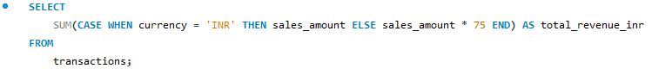

Output 1-



Ans- Total revenue till is 984.9M

Q.2) What is total orders?

Query 2-



Output 2

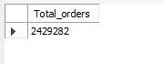

Ans- Total orders till is 2.5M

Q.3) Find total revenue by markets

Query 3-

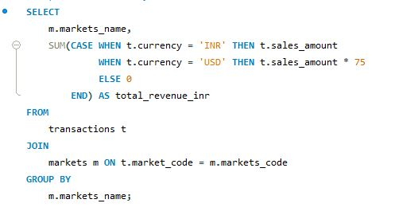

Output 3-

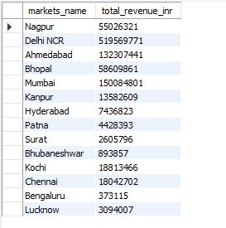

Ans – More revenue generated by Delhi NCR is 519.6M and less revenue generated by Bengaluru is 0.4M

Q.4) Find total Orders By markets

Query 4-

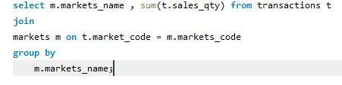

Output 4-

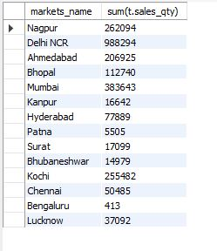

Ans- Maximum orders generated by Delhi NCR is 988.3K and less orders generated by Bengaluru is 0.4K

Q.5) Find top 5 customer by total revenue

Query 5-

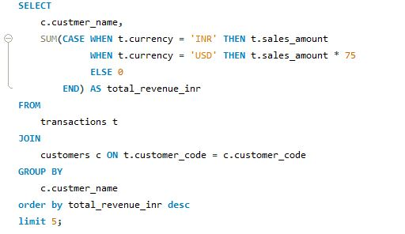

Output 5-

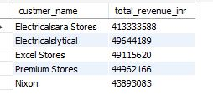

Ans- We generated more revenue from Electricalsara stores is 413.3M

Q.6) Find top 5 customer by total orders

Query 6-

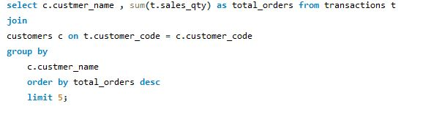

Output 6-

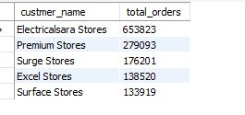

Ans- We got maximum orders from Electricalsara stores is 653.8K

Q.7) Find Total profit margin

Query 7-



Output 7-



Ans- Profit margin till is 2.4M

Q.8) Find revenue contribution percentage (%) by markets

Query 8-

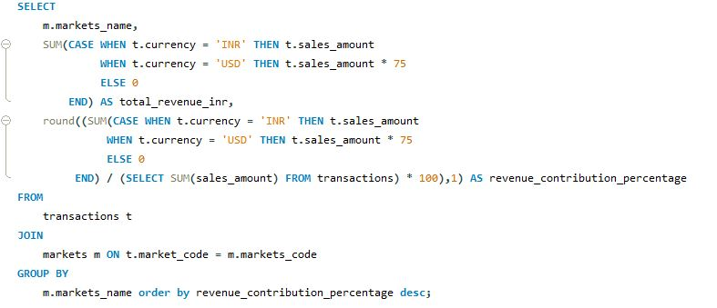

Output 8-

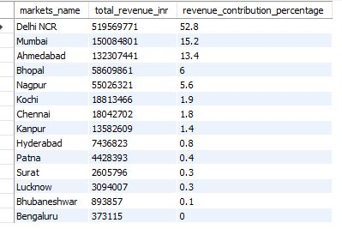

Ans- Delhi NCR is contributed more in revenue is 52.8% and Bengaluru contribution is less. we can see Bengaluru performance is very poor. So, we can either remove Bengaluru from our business or we can change our marketing strategy.

Q.9) Find Profit margin contribution percentage

Query 9-

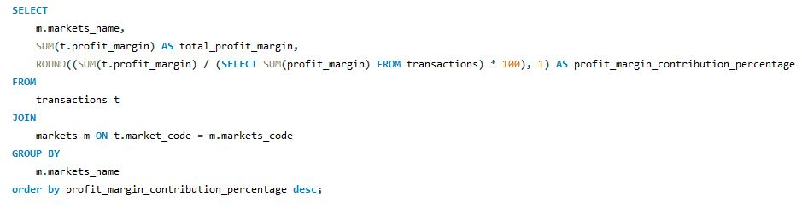

Output 9-

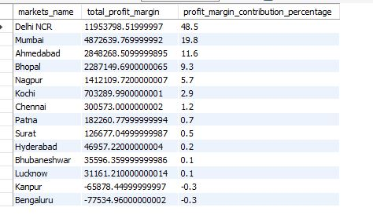

Ans- We got more profit margin from Delhi NCR and we not get any profits margin from Kanpur and Bengaluru.

So, we can remove Kanpur and Bengaluru from our business or we can change our marketing strategy for this area.

And also we focus on more in Delhi NCR for more profit.

Q.10) Find profit margin percentage

Query 10-

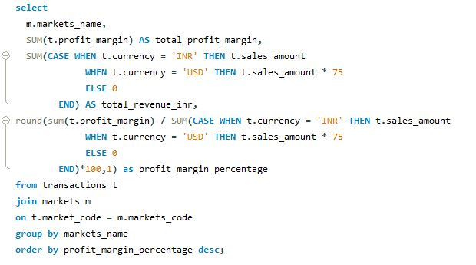

Output 10-

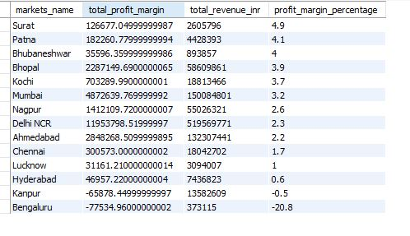

Ans- As per percentage we generated more profit margin from Surat.

Q.11) Find total revenue, revenue contribution percentage, total profit margin, profit margin percentage by customer

Query 11-

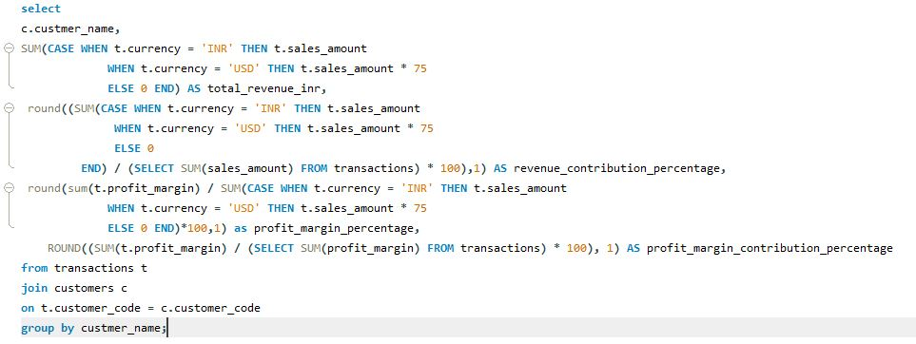

Output 11-

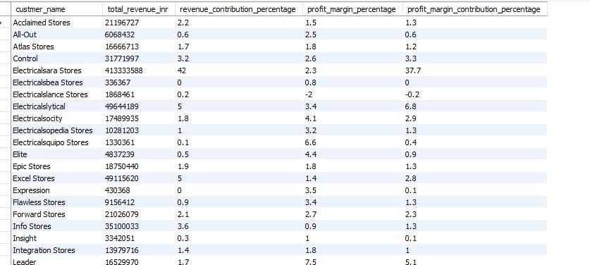

Ans- As we can see Electricalsara stores contributed in revenue is 42%, but we get more profit margin in % from Leader is 7.5%

Q.12) Current year total revenue (2020)

Query 12-

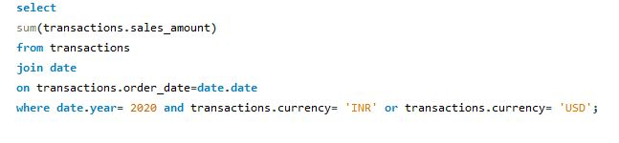

Output 12-



Ans- In current year (2020) our total revenue is 142.2M